- Display those employees whose salary is less than his manager but more than salary of any other managers.
SELECT empno, ename, sal
FROM employee e1
WHERE sal < (
SELECT sal FROM employee e2
WHERE e1.mgr = e2.empno
)
AND sal > ANY (
SELECT sal FROM employee
WHERE empno IN (SELECT DISTINCT mgr FROM employee)
);


- Find out the number of employees whose salary is greater than their manager salary?
SELECT COUNT(*) AS count
FROM employee e1
WHERE sal > (
SELECT sal FROM employee e2
WHERE e1.mgr = e2.empno
);

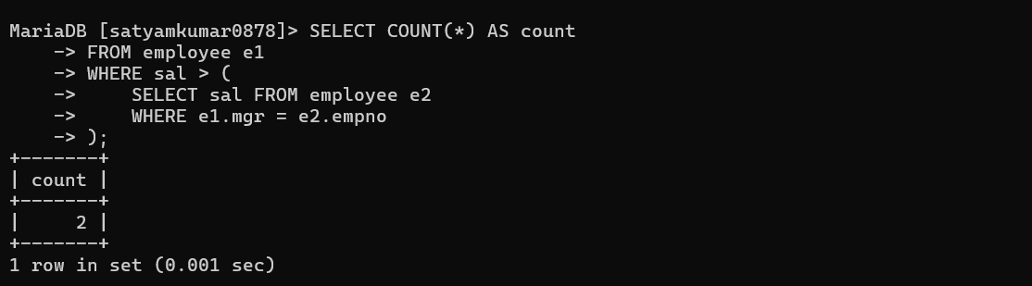
- Display those managers who are not working under president but they are working under any other manager?
SELECT empno, ename
FROM employee e1
WHERE empno IN (SELECT DISTINCT mgr FROM employee)
AND mgr != (
SELECT empno FROM employee WHERE job = 'PRESIDENT'
)
AND mgr IS NOT NULL;
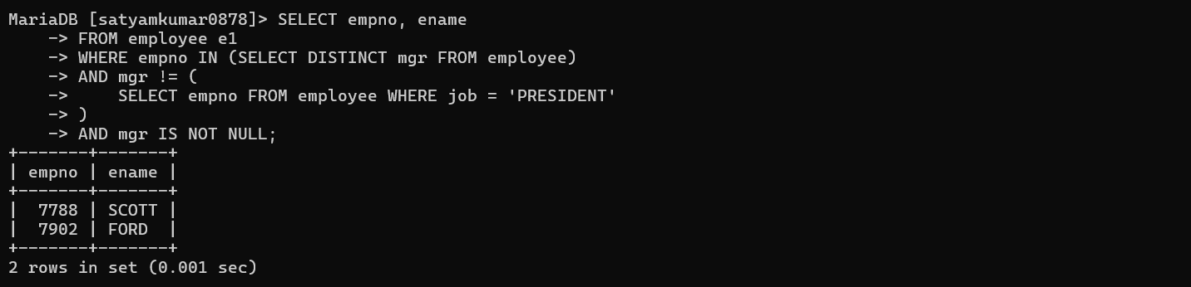

- Delete those department where no employee working?
DELETE FROM department
WHERE deptno NOT IN (
SELECT DISTINCT deptno FROM employee
);

- Delete those records from emp table whose deptno not available in dept table?
DELETE FROM employee
WHERE deptno NOT IN (
SELECT deptno FROM department
);

- Display those earners whose salary is out of the grade available in sal grade table?
SELECT empno, ename, sal, grade
FROM employee
WHERE grade IS NULL
OR grade NOT BETWEEN 'A' AND 'D';

- Display employee name, sal, comm. And whose net pay is greater than any other in the company?
SELECT empno, ename, sal, comm
FROM employee e1
WHERE sal + IFNULL(comm,0) >= ALL (
SELECT sal + IFNULL(comm,0)
FROM employee e2
WHERE e2.empno != e1.empno
);

- Display those employees who are working in sales or research?
SELECT empno, ename, dname
FROM employee e
JOIN department d
ON e.deptno = d.deptno
WHERE dname IN ('SALES', 'RESEARCH');

- Display the grade of jones?
SELECT empno, ename, grade
FROM employee
WHERE ename = 'JONES';

10. Display the department name the no of characters of which is equal to no of employees in any other department?
SELECT dname, LENGTH(dname)
FROM department d
WHERE LENGTH(d.dname) = ANY (
SELECT COUNT(*)
FROM employee e
WHERE e.deptno <> d.deptno
GROUP BY e.deptno
);


